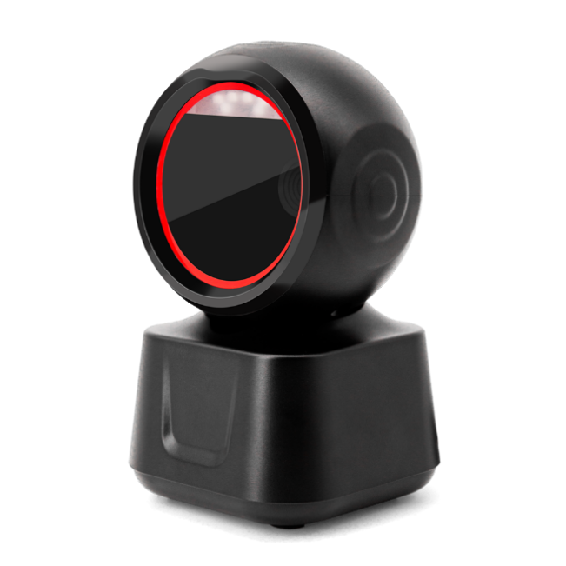

IBC-X6 high-speed 2D scanning platform
Product features
- Equipped with the new 300,000 global exposure scan engine
- Larger scanning window for easier reading
- Adjustable angle, flexible and easy to use
- Frequently used function buttons, easier to set up
- 4 styles of prompt sound, soft and bright LED indicator
- Rich interface, strong compatibility, support a variety of systems and cash registers

IBC-X6 technical parameters
Physical parameters
Scan mode | Auto-sensing/continuous scanning
Communication interface | USB-HID keyboard, USB-COM virtual serial port, RS232 serial port
Interface type | USB TYPE-B
Prompt mode | Buzzer, LED light
How it is set up | Press the key to set and manually scan the setting code in turn
Housing material | ABS+PC
Cable standard | Straight line 1.3m
Exterior dimensions | 158 mm×92mm×94mm(产品);1 70 mm×1 15 mm×115 mm(外包装)
Weight | Net weight 335g; Gross weight 345g
Performance parameters
Scan type | CMOS global exposure
Resolution | 640*480
Light source | 617nm red LED
Scan angle | ± 60°, ±54°, 360° (left and right, front and back, turn).
Scan rate | 120 times/sec
Field of view | 48° (H) x 30° (V)
Printing contrast | Minimum 20%.
Decoding kind | 1D: EAN13, EAN 8, UPC-A, UPC-E0, UPC-E1, Code128, Code39, Code93, Interleaved 2 of 5, Industrial 25, Matrix 2 of 5, Code11, CodeBar, MSI, RSS-14, RSS- Ltd, RSS- Exp, Standard 2 of 5, Plessey, ChinaPost 25, GS1 Composite  2D: QR Code, Data Matrix (DM), PDF417, Han Xin, Micro PDF417, Micro QRCode, MaxiCode, Aztec Code, Code16K, support mobile screen reading
Minimum resolution | 4 thousand
Electrical parameters
Input voltage | DC 5V±10%
Current | Working: 240 mAh; Standby: 190 mAh
Environment parameters
Temperature | 0°C-50°C (working); -20°C~+70°C (storage).
Humidity | 5%-95% non-condensing

The above data is subject to change without notice

